Project Design Phase-II
Data Flow Diagram & User Stories
Date | 24 October 2026
Team ID
Project Name | Incident Lifecycle Automation in ServiceNow
Maximum Marks | 4 Marks

Data Flow Diagrams
A Data Flow Diagram (DFD) shows how information moves through a system: who or what sends data in, which processes change it, where it is stored and what is sent back out. For this project, the DFD shows how an incident moves through ServiceNow from the moment it is reported until it is resolved and its knowledge article is created.

Example (Simplified)
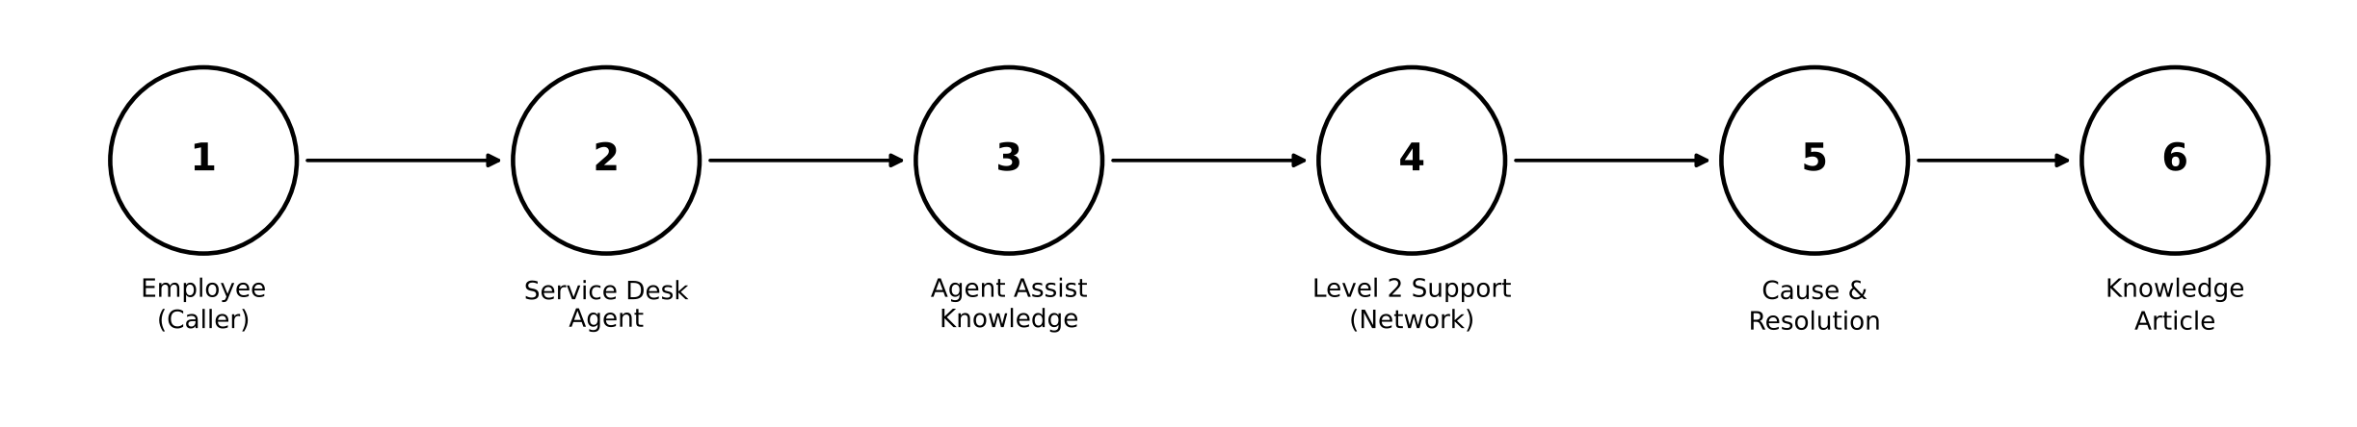
- The employee reports an IT issue, for example being unable to connect to the Corporate VPN from the home office.
- The Service Desk Agent creates the incident in Service Operations Workspace and classifies it with category, subcategory, urgency, service, service offering and configuration item.
- Agent Assist suggests knowledge articles. The agent marks one as helpful, attaches it, adds the watchers and reassigns the incident to the Network support group.
- The Level 2 technician takes the incident, updates the configuration item, puts it On Hold while a change is awaited, raises an emergency change request and creates a child incident.
- The probable cause, resolution code and resolution notes are recorded and the incident is resolved. SLA status stays visible on the incident.
- A knowledge article is created from the resolved incident in the IT knowledge base.
DFD Level 0: Incident Lifecycle Automation in ServiceNow
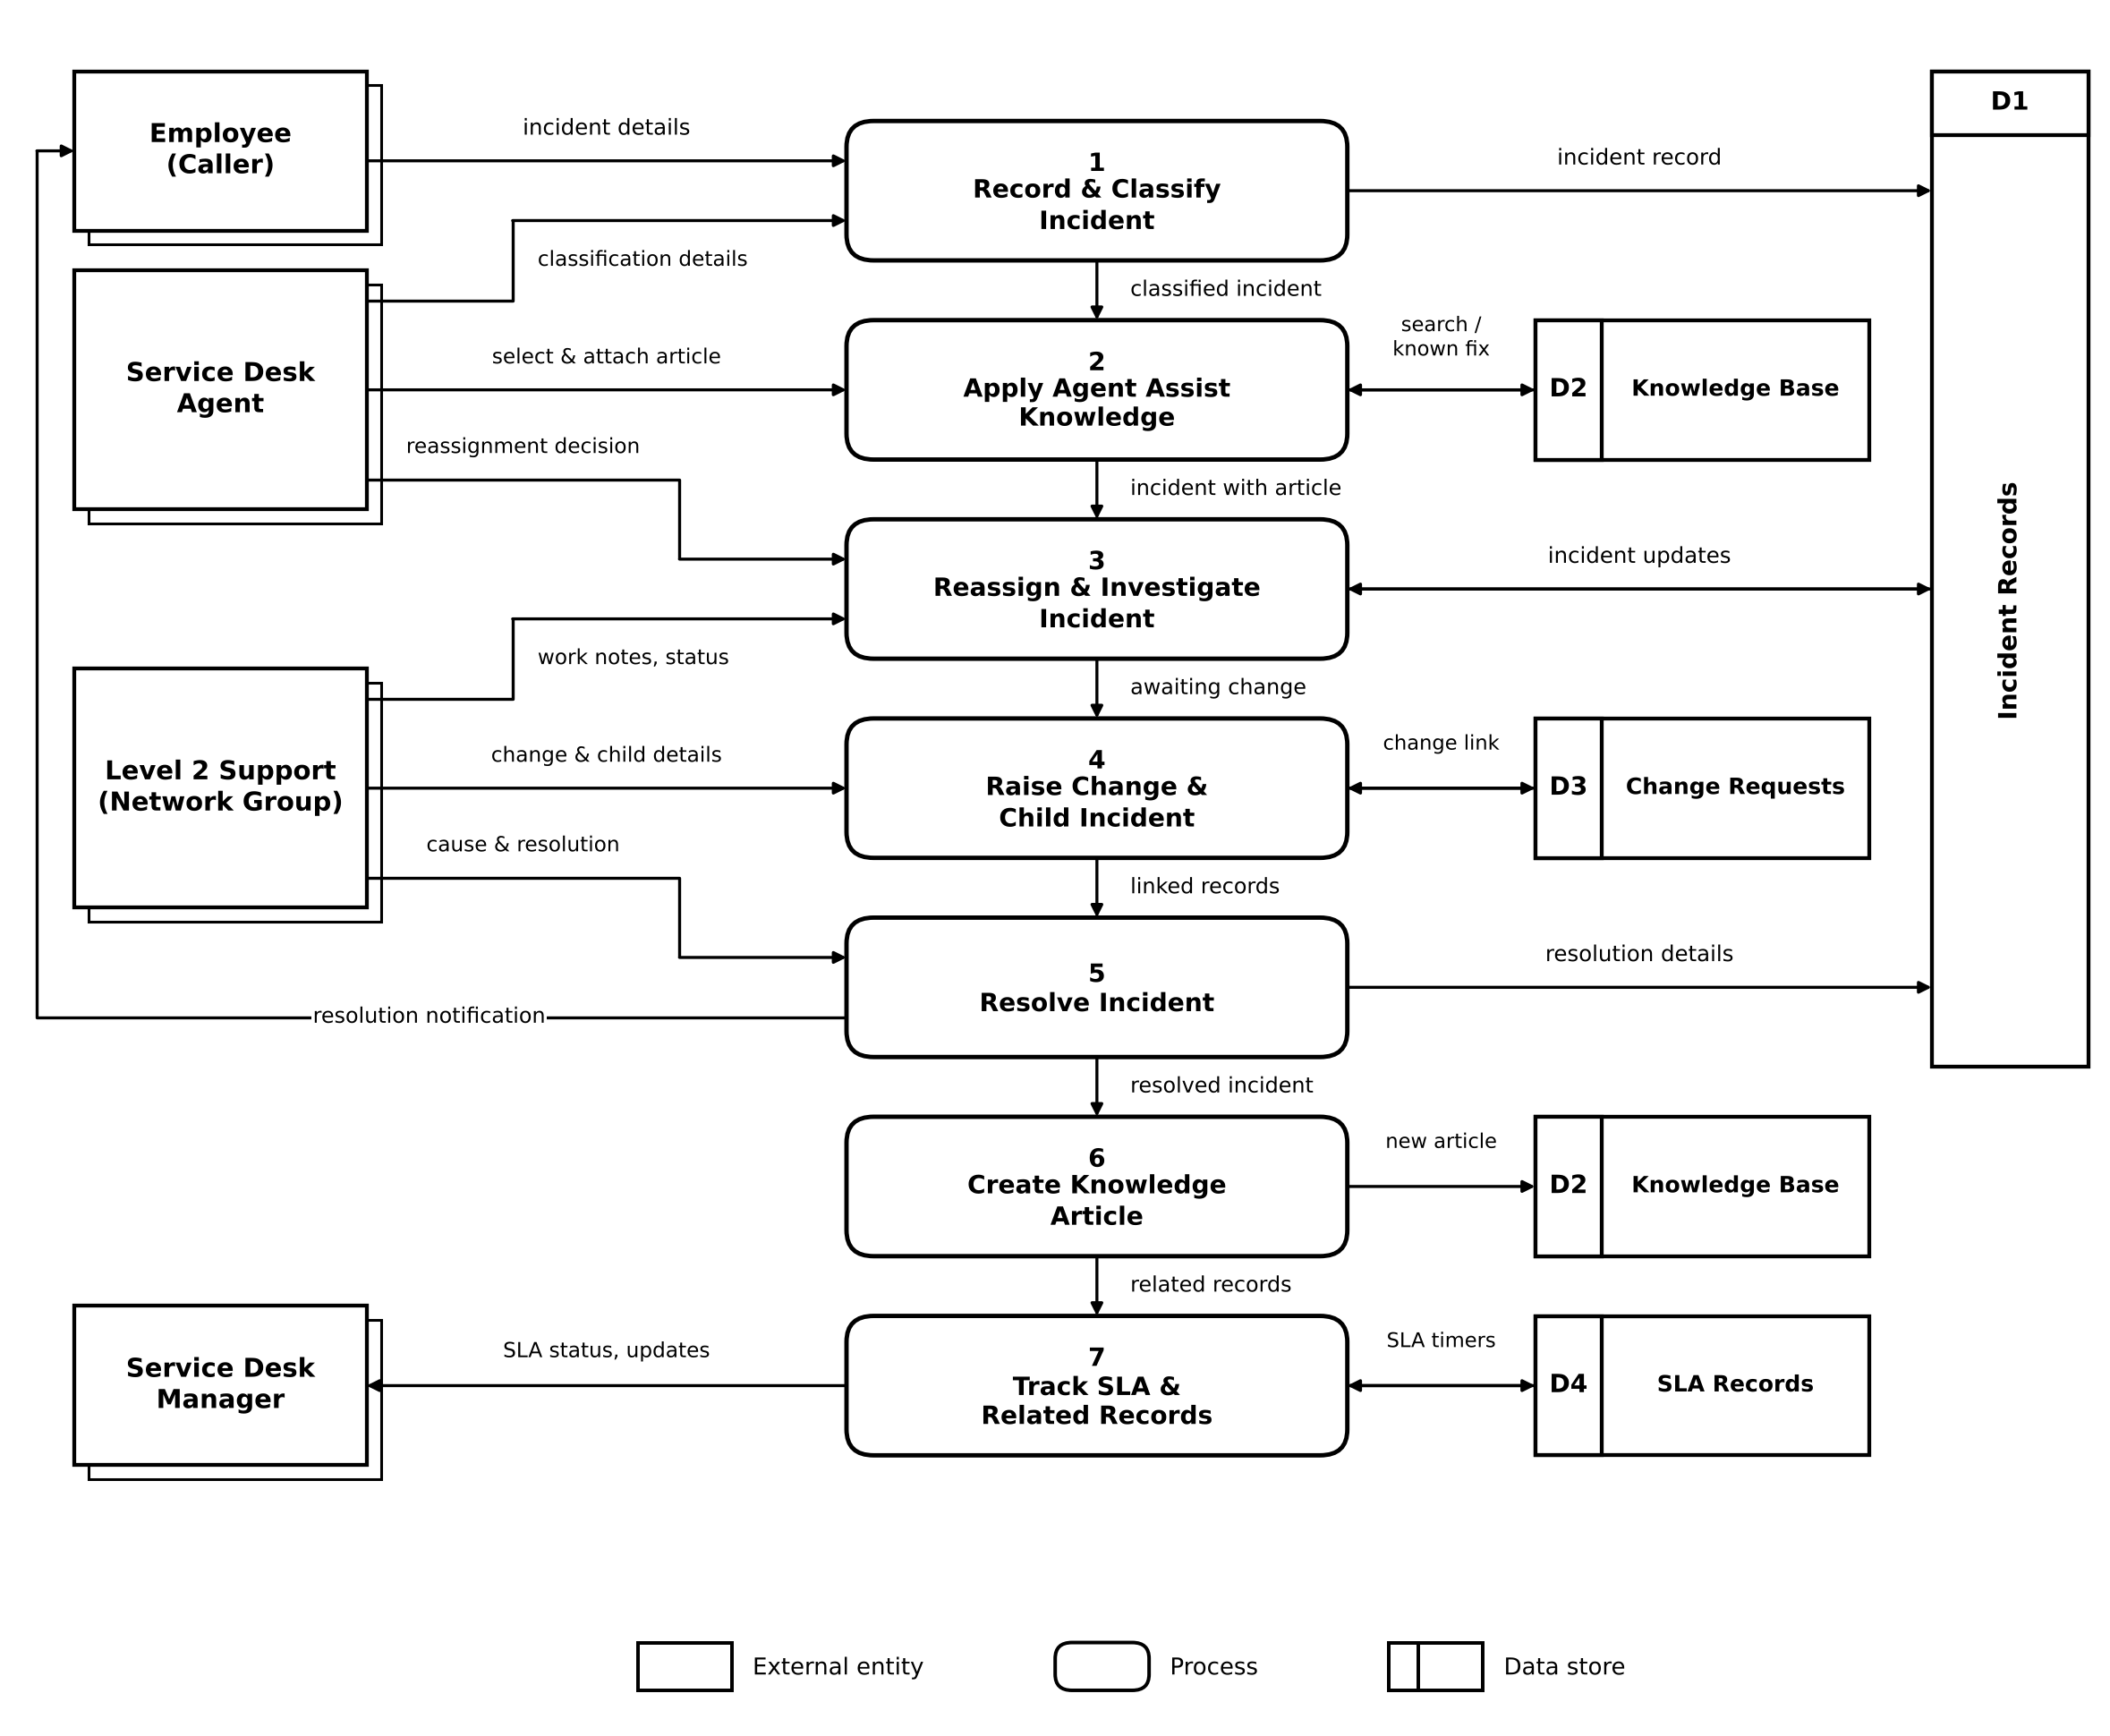

DFD Components
External entities | Employee (Caller), Service Desk Agent, Level 2 Support Group (Network) and Service Desk Manager
Processes | 1 Record & Classify Incident, 2 Apply Agent Assist Knowledge, 3 Reassign & Investigate Incident, 4 Raise Change & Child Incident, 5 Resolve Incident, 6 Create Knowledge Article, 7 Track SLA & Related Records
Data stores | D1 Incident Records, D2 Knowledge Base, D3 Change Requests, D4 SLA Records
Note | D2 Knowledge Base is drawn twice in Level 0 (for process 2 and process 6) so that flow lines do not cross. It is one data store.

User Stories
The table lists the user stories for the incident lifecycle, grouped by user type and functional requirement (epic).
User Type | Functional Requirement (Epic) | User Story Number | User Story / Task | Acceptance criteria | Priority | Release
Employee (Caller) | Incident Reporting | USN-1 | As an employee, I can report that I cannot connect to the Corporate VPN from home so that an incident is logged for me. | An incident is created with me as the caller and a short description, and an incident number is generated. | High | Sprint-1
Employee (Caller) | Resolution Update | USN-2 | As an employee, I can have my VPN incident resolved so that I can work from home again. | The incident shows the state Resolved with the cause and resolution notes. | Medium | Sprint-3
Service Desk Agent | Incident Record Creation | USN-3 | As an agent, I can create a new incident in Service Operations Workspace with a short description and the caller, and set the assignment group to Service Desk. | The incident saves and appears in the Open incidents list. | High | Sprint-1
Service Desk Agent | Incident Classification | USN-4 | As an agent, I can record the description and channel and set the category, subcategory and urgency. | Category Network, subcategory VPN, urgency 2 - Medium and channel Phone are saved on the incident. | High | Sprint-1
Service Desk Agent | Incident Classification | USN-5 | As an agent, I can select the service, service offering and configuration item. | Remote Access, Corporate VPN and a configuration item are saved and visible on the Details tab. | High | Sprint-1
Service Desk Agent | Incident Classification | USN-6 | As an agent, I can add a work note and assign the incident to myself. | The work note appears in the activity log and the incident shows me as the assignee. | Medium | Sprint-1
Service Desk Agent | Knowledge Integration (Agent Assist) | USN-7 | As an agent, I can see knowledge articles suggested by Agent Assist from the short description. | Matching articles are listed in the Agent Assist panel. | High | Sprint-2
Service Desk Agent | Knowledge Integration (Agent Assist) | USN-8 | As an agent, I can mark an article as helpful and attach it with a comment. | The article is linked in the activity log and the helpful indicator is marked. | Medium | Sprint-2
Service Desk Agent | Reassignment & Escalation | USN-9 | As an agent, I can add a watcher and a work notes follower to the incident. | Samantha Bordwell is on the Watch list and Beth Anglin is on the Work notes list. | Medium | Sprint-2
Service Desk Agent | Reassignment & Escalation | USN-10 | As an agent, I can reassign the incident to the Network group. | The assignment group is Network and the Assigned to field clears automatically. | High | Sprint-2
Level 2 Technician (Network) | Investigation | USN-11 | As a technician, I can open the VPN incident from the Open incidents list and assign it to myself. | The description, knowledge articles and Task SLAs are visible on the incident. | High | Sprint-2
Level 2 Technician (Network) | Investigation | USN-12 | As a technician, I can update the configuration item to PowerEdge and put the incident On Hold. | The configuration item is saved and the state is On Hold with the reason Awaiting Change. | Medium | Sprint-3
Level 2 Technician (Network) | Change & Related Incidents | USN-13 | As a technician, I can create an emergency change request from the incident. | The change request is created and linked to the incident in Related Records. | High | Sprint-3
Level 2 Technician (Network) | Change & Related Incidents | USN-14 | As a technician, I can create a child incident from Related Records. | The child incident is listed under Child Incidents of the parent incident. | Medium | Sprint-3
Level 2 Technician (Network) | Incident Resolution | USN-15 | As a technician, I can record the probable cause on the Overview tab. | The probable cause is saved on the incident. | High | Sprint-3
Level 2 Technician (Network) | Incident Resolution | USN-16 | As a technician, I can record the resolution code and notes and resolve the incident after confirming. | The incident state is Resolved and the child incident is also Resolved. | High | Sprint-3
Level 2 Technician (Network) | Knowledge Creation | USN-17 | As a technician, I can create a knowledge article from the resolved incident using the IT knowledge base and the Standard template. | The article is saved and listed in Related Records of the parent incident. | Medium | Sprint-3
Service Desk Manager | Tracking & SLA | USN-18 | As a manager, I can follow the incident through the Watch list. | I receive updates on the incident as it moves between teams. | Medium | Sprint-2
Service Desk Manager | Tracking & SLA | USN-19 | As a manager, I can view the Task SLAs in Related Records. | SLA information is visible on the incident and its related records. | High | Sprint-2
Administrator | Service Setup | USN-20 | As an administrator, I can create the service Remote Access and the service offering Corporate VPN. | Both are Operational and can be selected on the incident form. | High | Sprint-1
Administrator | Access | USN-21 | As an administrator, I can impersonate users such as Beth Anglin and David Loo to test their roles. | Each user sees the workspace and incidents allowed for their role. | Medium | Sprint-1

Priority and Release Notes
High priority stories are needed for the core incident lifecycle: recording, classification, knowledge, reassignment, change, resolution and SLA visibility. Medium priority stories add convenience and traceability.
Sprint-1 covers setup, incident creation and classification. Sprint-2 adds Agent Assist knowledge, reassignment, watchers and SLA visibility. Sprint-3 covers investigation updates, the emergency change request, the child incident, resolution and knowledge creation.

